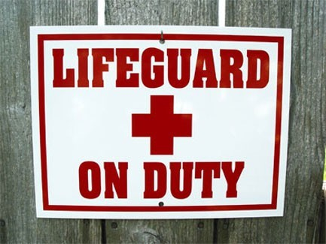Sarnia Riding Club  
Spring Pool Schedule 2016  
Friday, May 20th – Friday, July 1st, 2016 *OPEN HOUSE, Sunday, May 15th …pool open!*

|  |  |  |  |  |  |  |
| --- | --- | --- | --- | --- | --- | --- |
|  | **Monday** | **Tuesday** | **Wednesday** | **Thursday** | **Friday** | **Weekend** |
| **6:00** |  |  |  |  |  |  |
| **7:00** |  |
| **8:00** |  | | | | |  |
| **9:00** |  | | | | |  |
| **10:00** |  | | | | |  |
|  |
| **11:00** |  |
| **12:00** | Open Swim 4pm – 6pm  When weather warms up we will change to 3pm | | | | | Open Swim  12-6pm  *If we get some warm weather we will open earlier & communicate.* |
| **1:00** |
| **2:00** |
| **3:00** |
| **4:00** |
| **5:00** |
| **6:00** | Adult Swim 6pm – 7pm  Adult Swim | | | | | |
| **7:00** | Open Swim 7 – 9 pm | | | | | |
| **8:00** |
| **9:00** |
| **Pool Closes** |  | 9:00 | 9:00 | 9:00 | 9:00 | 9:00 |
|  |  |  |  |  |  |  |