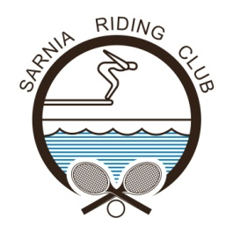
2019 SPRING JUNIOR TENNIS LESSONS

The Sarnia Riding Club is offering a six-week junior tennis lesson program for children ages 5+.
The Junior Tennis Programs are broken down by age group and experience. Each child will be evaluated and placed in the appropriate class for their first day of attendance. From there they will learn the fundamental skills of the game of tennis, learn the rules of the game, be physically active and most importantly- HAVE FUN!

WHEN: Monday, May 20th, 2019 through to Thursday, June 27th, 2019

Monday & Wednesday, 4pm-5pm or 5pm-6pm
Tuesday & Thursday, 4pm-5pm or 5pm-6pm

WHERE: Meet on courts 5 and 6 near the tennis shed

PRICE: Sarnia Riding Club Members: $90; Non-Members: $140

Registration deadline is Thursday, May 16th, 2019 by 12:00 PM (Noon)

Questions? Please email rec@sarniaridingclub.com or call the office at 519.542.5588 ext. 2
______________________________________________________________________________________________________________________

MEMBER or NON-MEMBER (Please circle one)

Name: ___________________________________________________________________________________________________

Age & Date of Birth: ____________________________________________________________________________________

Previous Tennis Experience: __________________________________________________________________________

Phone Number (Most accessible):____________________________________________________________________

Home Address: _________________________________________________________________________________________

E-Mail Address: _________________________________________________________________________________________

Preferred Days (Please circle): Monday & Wednesday OR Tuesday & Thursday

Sarnia Riding Club
980 Riding Club Lane, Sarnia, ON, N7V 4J2

