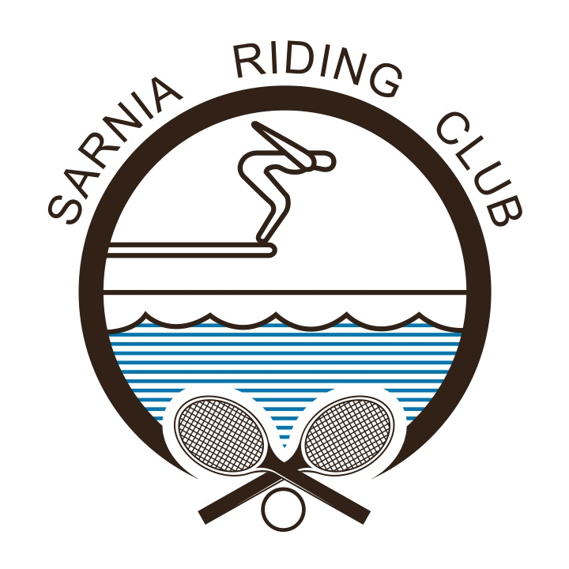
2019 SUMMER JUNIOR TENNIS LESSONS

The junior tennis lesson program will be offered throughout the summer and broken down into four, two week sessions, plus one, one week session at the end of the season.

The organization of classes is based on age groups and experience; children must be at least four to participate.
SESSION ONE (9 days- Canada Day Holiday)  - Tuesday, July 2nd – Friday, July 12th  - Beginner: Member $35 / Non Member $55  - Beginner Advanced: Member $55/Non Member $85  - Intermediate: Member $72/ Non Member $105 | SESSION TWO  - Monday, July 15th – Friday, July 26th  - Beginner: Member $40/ Non Member $60  - Beginner Advanced: Member $60/Non Member $90  - Intermediate: Member $80/Non Member $120
SESSION THREE (9 days – Civic Holiday Monday)  - Monday, July 29th – Friday, August 9th  - Beginner: Member $35 / Non Member $55  - Beginner Advanced: Member $55/Non Member $85  - Intermediate: Member $72/ Non Member $105 | SESSION FOUR  - Monday, August 12th – Friday, August 23rd  - Beginner: Member $40/ Non Member $60  - Beginner Advanced: Member $60/Non Member $90  - Intermediate: Member $80/Non Member $120

SESSION FIVE – 5 DAYS ONLY
- Monday, August 26th – Friday, August 30th
- Beginner: Member $29/Non Member $30
- Beginner Advanced: Member $30/Non Member $45
- Intermediate: Member $40/Non Member $60

Registration Form
Registration deadline is due week prior of each session. Registration received after deadline date requires a $20 family late registration fee.

Players Name: ______________________________________________________________________________________________________________

Age: ________________Session number(s): _________________________ Member: _________________ Non-Member: __________

Contact Name: _____________________________________________________________________________________________________________

Email: _______________________________________________________________Cell: ____________________________________________________
Previous Experience: __________________________________________________________________________________________________

Please note any allergies or medical conditions: ______________________________________________________________________
If you have any questions, please email Corry Lester at rec@sarniaridingclub.com We will do our very best to accommodate your schedule. Inclement weather policy: no refunds; no make-up classes.

