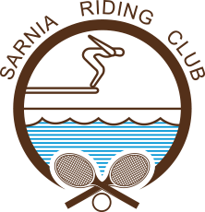
Rusty Racquets 2019
Rusty Racquets is designed for members and non-members who are new to tennis and/or who have not played in a number of years. These sessions are meant to develop/improve your basic strokes and learn more about the art of doubles tennis. Under the guidance of our Tennis Instructors, half of the classes will be clinics and half will be doubles play.

Summer Session Dates: Wednesday, July 3rd- Wednesday, August 28th/2019, 6:00 pm-7:00 pm
Cost Per Session:
$60/Member
$80/Non-Member
Name:____________________________________________ Member/Non-Member:_____________

Phone Number:__________________________________

Email Address:_____________________________________

Street Address:_____________________________________

Postal Code: _____________________ City:_________________________

